Development of Comics Learning Media for Buy and Sale Practices on Social Aritmetic Materials
Class VII MTsN 2 Mojokerto

Husnuz Zaimah

Mathematics teacher of MTsN 2 Mojokerto, East Java

Abstract
The research was undertaken to give an overview of how development of comics learning media that is feasible and effective for mathematics teaching and learning process. This study was a developmental study adapting some stages from Borg and Gall. The stages namely 1) conducting research and information gathering, (2) conducting planning, (3) developing initial product formats, (4) design validation, (5) ) revising design validation, (6) major field trials, (7) revising products, (8) conducting operational field tests, (9) conducting product effectiveness tests; and (10) Revision of the final product. Based on validation results, the comics media for buy and sale practices on Social Arithmetic materials got 96% score from material experts and 93.6% from media experts. Based on the effectiveness test on students of class VII MTs N 2 Mojokerto, it has been shown that the experimental class scores got an average score of 76.91 while the control class gained 48.5. In addition, the results of the T-test 0.01 also lead to the conclusion that this comic media is feasible to be used as a learning media on the topic of Social Arithmetic.

Keywords: development, comic media, buying and selling practices.

Introduction

The formulation of mathematical discussion is not only by determining the relationship of patterns, shapes and assemblies as the target. The four goals are merely emphasizing that mathematics concerns abstract notions. Hudoyo (2013) states that learning mathematics is a high mental activity. So in teaching mathematics the teacher must be able to provide a good explanation so that abstract mathematical concepts can be understood.
From the above opinion it can be said that it takes the ability of a teacher to concretize mathematical concepts so that students more easily understand. Likewise Z.P Dienes (1992) argues that each concept or principle in mathematics which is presented in a concrete form will be well understood. This means that objects or objects in tangible form will play a very important role when manipulated properly in teaching mathematics.
Assistance in any form that can function as a messenger in achieving goals according to Syaiful Bahri Djamarah (2002) referred to as the media. Whereas Gagne argues that media are various types of components in the student environment that can stimulate students to learn.
Generally, the types of media can be divided into: visual media, audio media and audiovisual media. Visual Media is media that can be seen, read and touched. This media relies on the sense of sight and touch. These types of media are so many, very easy to get as well as to make by yourself. For instance, photo media, images, comics, sticky images, posters, magazines, books, miniatures, props are some kind of visual media. On the other side, Audio media is media that has sound. Example radio and music. An audiovisual media is media that has sound and picture elements such as LCD project, film projector,TV,computer,VCD player, virtual classroom, multimedia etc.
As one of visual media, comics are two-dimensional media in the form of sheets and contain several panels containing textual images. Waluyanto (2005) states that the panels contained in the comic sheet have an adjacent and sequential structure so that information is conveyed with. In fact, the comic media aside from displaying entertaining images or visuals, but also a high-powered pictorial media in conveying information in an interesting and interesting way. Why Because the panels in the comic have a balloon of text that is light-hearted and shows information in an orderly, concise, easy and memorable way.
Rohani (1997) says that media which are clear, easy to understand are simple, have a communicative and persona nature. The delivery of messages in effective learning can be through comic media in Waluyanto (2005). From this statement it can be said that comics as a good and interesting alternative media in learning.
In the matter of Social Arithmetic there are subjects selling price, purchase price, profit, loss, discount. In assigning assignments, there are many grades of students that are less than KKM (Kriteria Ketuntasan Minimal), so researchers need to carry out simulations of buying and selling practices aimed at introducing students directly in understanding Social Arithmetic material. Students can be directly involved to feel the seller. Students are required to be creative in offering their merchandise for behavior such as giving a discounted price, arranging interesting items, and calculating profit or loss. While students who act as buyers can also feel directly the role as buyers who practice how to bargain the price of goods and spend money in such a way that economic principles can work as they should. The practice of buying and selling is made into comic-based media so students can easily understand and are interested in learning. According to the results of the questionnaire distributed to students (table 1) to find out the needs of students for the presence of learning comics regarding the practice of buying and selling, shows the results that students are interested in using buying and selling practice comic media.
According to the statement above, the researcher wants to develop a learning comic media that contains the practice of buying and selling activities that can be applied by the students in terms of their understanding in Social Arithmetic material.
Learning comic media is packaged in the form of picture and colored books that contain interactive dialogue pictures that tell the process of buying and selling practices in a comprehensive and detailed manner.

Scene section
Which contains photos of practice
memuat foto praktik di kls

Insert stickers to express students' emotions

Input balloon text dialog

The panel section that contains scenes

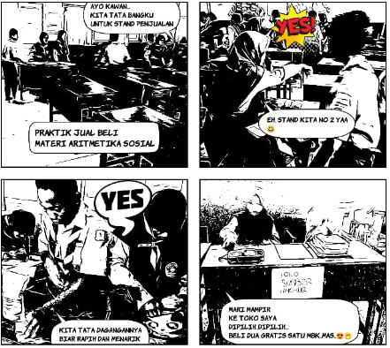
Figure 1. Prototype of learning comic buying and selling media

Based on the specifications as mentioned above, it is necessary to develop research aimed at producing multimedia-based learning media in the form of learning comics selling and buying on Social Arithmetic material.
The results of this study provide the availability of learning comics media buying and selling practices on Social Arithmetic material. Based on the needs of students, teachers and madrassas and is expected to make the learning process more communicative and enjoyable.
The following is presented relevant research by discussing the problems in accordance with this research, namely Indaryati, Jailani (2015) “Development of Mathematics Learning Comic Media Improving Student Motivation and Learning Achievement in Class V”, Prima Edukasia Journal, Volume 3 – Number 1, 2015, State University Jogja; Nurul Hidayah (2017) in “Development of Comic-Based Learning Media in Social Sciences Subject Class IV MI Nurul Hidayah Roworejo Negeri Katon Pesawaran” in the Journal of Education and Basic Learning Vol 4 No 1; Sutrisno (2018) in “Development of Physics comics as a learning media for subject matter of motion”, Repositories of Raden Intan University Lampung E-Journal TP Vol III, No. 7 (2018) shows that the difference in each study to be developed with previous research is material , development methods, and types of media that will be used in the learning media creation program. (Appendix, Table 1). The relevant research results show that comics are suitable as learning media. Researchers use non-fictional images because they take photos of buying and selling practices by students in the classroom as material for comic concepts through the application of comics and comic life 3.

Research Design
This research is a type of Research and Development (R&D) research. Borg & Gall (1983) states "The notion of development research is a process used to develop and validate educational products".
The development procedure was adapted from Borg & Gall's (1983) theory through 10 stages, namely (1) conducting research and information gathering, (2) planning, (3) developing initial product formats, (4) design validation, (5) making revisions design validation, (6) first trial (7) revising the product, (8) conducting a second trial (9) conducting an effectiveness test on the product, and (10) revising the final product.
The product developed in this development research has the expected specifications to contain: (1) This product is based on multimedia media using the application comica and comic life 3 (2) Two-dimensional shape in the form of sheets of paper and put together into a book (3) Each sheet contains several panels which contains scene scenes (4) Contains ballon texts in the form of dialogs of students' daily conversations about the process of buying and selling practices on Social Arithmetic material.

Flow of Adaptation Research Procedures from Borg & Gall
8. Operational field trial
4. Design validity
1. Information gathering
10. Field final product revision
9. Product effectiveness test
7. Product revision 2
6. Main field trials
5. Product revision 1
3. Initial product development
2. Media planning

Figure 2. The research procedure presented in the flow

The research and data collection phases are done in the form of Research and Development (R&D) research and it is included into (pra survey) research. There are subject matters in Social Arithmetic that consists of buying price, selling price, profit, profit or loss percentage, and discount. The researcher makes a practice for the students in the form of selling and buying to make sure they can apply the material of Social Arithmetic. In this case, there are two groups, seller and buyer. Each of them is given duty according to the clue given. Therefore, the 34 students are divided into 6 groups and each group consists of 3 buyers and 3 sellers. The duty of sellers and buyers are attached in (attachment 1).
Planning to make learning comic media begins by documenting each stage of the practice of buying and selling. Starting from giving direction instructions, structuring sales stands, other preparations. The initial media product was a JPEG format photo which contained the process of buying and selling activities and continued with the installation of an Android-based comica application through the app store. The making of comic media is determined by the number of multi-slide variations available in the options menu, the type of text ballon and the type of comic convert. (Picture 1)
The research design validation is having consultation to the Mathematic teacher who is a peer and IT teacher as the material and media experts. The validator is given a chance to give feedback and recommendation to the learning media improvement. This phase would be done when the design validation got criticism and recommendation that should be revised.
In this stage, the main field trial was conducted on a limited group trial conducted on 17 students. The test is done by using learning comic media. The results of the questionnaire assessment (questionnaire) are intended to improve and perfect the media that will be tested on operational field tests.
This stage contains criticisms and suggestions on the assessment of the results of the questionnaire which will be used as material for revision. The existence of product revision is if the product is still not effective with a product trial and gets comments because there are still weaknesses in the media so that it can be fixed and fixed first. Here the Research uses the comic life 3 application before an operational field test.
This field test was conducted on 34 students. The test was carried out using learning comic media which contained more varied pictures and detailed dialogues in class as well as filling in the assessment questionnaire.
By revising the product, the teaching aids are corrected according to the results of the data obtained. After being repaired and tidied and tested T to see its effectiveness, the product is ready to be made.
The final product of this comic media is packaged in the form of a printed book containing color pictures and tells the process of buying and selling practices on social arithmetic materials. On the first page are instructions for the seller and buyer groups. The final page includes a student worksheet.
Research result
Early stage
This stage includes: preparation (student analysis, curriculum) and designing (documentation of each stage in the seller and buyer groups, making comics using the comica and comic life applications

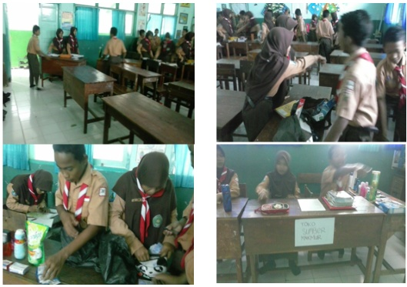
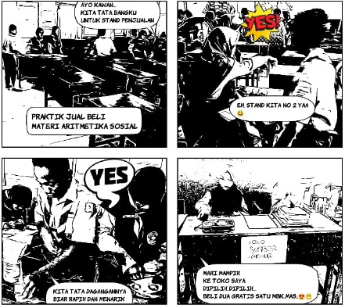

Figure 3. First Prototype
Table 3
Revision Decision (Design validation stage 1)

Comment/Recommendation | Revision Decision
Material Expert | Material Expert
a. The initial instructions were explained as there was a picture of the teacher giving the order to arrange a bench for the booth  b. The character should be given a name | a. Slides are given by the teacher to give direction When students have to set up a booth  b. The character's name is raised
Media Expert | Media Expert
a. Color is too bold  b. It is better to have a frame to make it interesting  c. There are color variations | a. The color was revised to be brighter  b. Each scene is given a frame  c. Color variations are given

Validation on Media and Material Experts
Media experts validate learning comic media on media use, work functions, visual form aesthetics, benefits of learning. Whereas material experts validate the relationship with the competency of teaching materials, the procedure of buying and selling transactions, the task of the seller group and the buyer group.
Material and media validators, through these stages obtained data that will be used to make product revisions, so that the resulting product is valid / feasible. Data collection instruments in the form of interviews and questionnaires. To calculate the percentage score on the validation questionnaire from material experts, media experts, and students, the formula used is as follows.
V – ah = $\frac{Tse}{Tsh }$ $×100\%$ (1)
V – au = $\frac{Tse}{Tsh }$ $×100\%$ (2)
Formula Description:
V-ah = Expert validity
V-au = Audience (student) validity
Tse = Total empirical score achieved (based on expert, audience ratings)
Tsh = Expected total score
100 = A constant
Akbar (2013)
The product results that have been validated by the validator are carried out by an assessment mechanism of the media in the form of a questionnaire. In its implementation, material experts and media experts use and examine products, then experts provide assessments, comments, and revision suggestions. The results of the analysis are known from the validator shows that the material expert validator gives a percentage score of 96% and the media expert validator gives a percentage score of 93.6%, it can be concluded that the learning comics developed can be categorized as valid so that it is feasible as a learning comic media for buying and selling practices on social arithmetic material to be tested on users.

First Trial Data Presentation
Material and media experts have validated the media. The result of validation showed a score of 82.30%. It means that changes for learning comics selling practice are needed. After revision, the next step was conducting the main field trial to 17 students. Researchers explain the systematic way to fill out the questionnaire to students. During the trial, students seemed to be concentrated and enthusiastic.

Second design revision

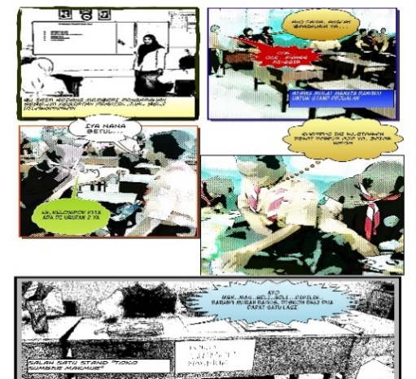
Figure 4. Second Prototype

Table 4
Revision Decisions (Design phase II Validation)

Comment/Recommendation | Revision Decision
Material Expert | Material Exert
- Slides are given by the teacher to give direction When students have to set up a booth  b. The figure is given a name | a. Has been done  b. Has been done
Media Expert | Media Expert
a. Bright colors  b. It is better to have a frame to make it interesting  c. There are color variations | a. Has been done  b. Each scene is given a frame  c. Given variations in color, especially on the balloon text to make it interesting

Presentation of Second Trial data
The last stage of the trial was the practice of buying and selling learning comic media which received validation from 34 students. When testing students actively understand the contents of the material by trying, and using media well. After understanding the material, students seemed excited and enthusiastic in practicing the simulation of buying and selling activities on Social Arithmetic material. The validation results showed 92.31%.

Test the effectiveness of the product
Given the pretest and posttest questions in the test class and control class. The results of the processing of the post test scores of the trial and control classes using SPSS 20.0 were analyzed so that they reached conclusions whether the learning comic media product of buying and selling practices on Social Arithmetic material was effective or not.

Final product revision
Done as a revision of the final refinement of learning comic buying and selling media on Social Arithmetic material.

Data Analysis

In this research development, two data analysis techniques were used, namely qualitative data analysis techniques and quantitative data analysis in making decisions on multimedia-based learning media products: "Learning Practice Comic Learning on Social Arithmetic Material" was declared valid / feasible. The results of the analysis are then used to revise the developed product.
The results of the initial trial validation calculation by material experts were 96% and media experts were 93.6%, so it can be said that if the validated media reaches a percentage level of 81% -100%, then the media are classified as very valid qualifications. So that the learning media "Learning comic buying and selling practice on Social Arithmetic material" is feasible as a learning medium used in the learning process.
The results of calculating the total validation of 17 students' field trials on learning media developed by researchers were 82.30%, so it can be said that if the validated media reaches a percentage level of 81% - 100%, then the media are classified as very valid qualifications. So the learning media "Comic learning practice of buying and selling on Social Arithmetic material" can be used in the learning process without improvement based on the criteria of achieving value (effectiveness) according to Akbar (2013).
Based on the qualitative data of the results of expert validation, it is obtained criticism, suggestions, and general opinion that (1) Color variations in the ballon text should be added. (2) The character's name is raised so that the dialogue is interactive to be interesting, (3) Each part of the slide should be framed in order to clearly distinguish each scene (4) Facilitate learning and better understand the material presented, (5) The medium can facilitate students to learn independently.
The results of calculating the total validation of 34 students' field tests on learning media developed by researchers were 92.31%, so it can be said that if the validated media reaches a percentage level of 81% - 100%, then the media are classified as very valid qualifications. So the media "Learning Comic Learning Practice" can be used in the learning process.
The revision of product development research is a conclusion that was drawn from the data analysis result from the expert and students in the form of validated products as the basic of the revision. Based on the data analysis result from the validator material expert, media expert and students, it can be concluded that “Comic Learning of Selling and Buying Practice” is valid and worthy to be used as the learning media in the learning process. Before this media is applied in the learning process, the product of learning media was revised in advance according to the feedback and recommendation. The supported data can be seen in table 9.

Table 9
Media Wealth Results
The product results that have been validated as follows
development of comics learning media for buy and sale practices
on social arithmetic materials

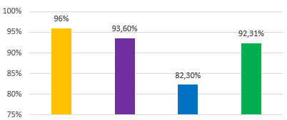
Material Expert

Big Trial Class

Small Trial Class
Media Expert

= Material Expert
= Media Expert
= Small Trial Class
= Big Trial Class

The results of processing the effectiveness test through the post test value of the test class and the control class using SPSS 20.0 can be seen in the following table 10 :

Table 10
The average post-test of the Control class and the Try-out class were analyzed by the SPSS 20.0 program

 | Kelas | N | Mean | Std.Deviation | Std. Error Mean
POSTEST | 1.00 | 34 | 48.5000 | 12.43955 | 2.13337
POSTEST | 2.00 | 34 | 76.9118 | 5.94096 | 1.01887

From table 10 above it can be seen that the average control class (VII E) is 48.5. While the average class of trials (VII D) is 76.91. From these data it is known that the average grade VII who uses learning comics media buying and selling practices on Social Arithmetic material is higher than class VII E who does not use media. While the Independent T-test data from the test and control class can be shown in table 11.

Table 11
T-test results for the significance of the difference between the Control class and the Test class using the SPSS 20.0 program
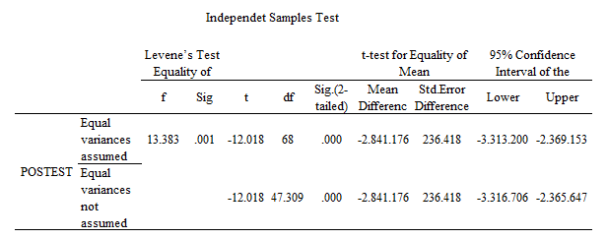
From table 11 it can be seen that the significance value (2-tailed) is 0.01. If the significance value < of 0.05, then found a significant difference between learning outcomes of class VII E and VII D Raharjo (2017). That is, the learning comics of buying and selling practices on Social Arithmetic material is effective as a medium to improve student learning outcomes.

Conclusions and Suggestions
Based on the results of the study, it was found that the development of the media "Learning Comic Learning Practice on Arithmetic Material" can improve students’ understanding easily and fun. The results of the media trial "The Practice of Buying and Selling Comics on Material Arithmetic" produced several conclusions as follows: (a) Design validation by material experts, with the results of questionnaire data analysis showing 96. While the design by media experts, the results of questionnaire data analysis showed amounted to 93.6%, it can be concluded that the media "Learning Comic Learning Practice on Social Arithmetic Material" is very effective and very valid based on a table of achievement criteria (effectiveness), (b) Main field trials of 17 students, with the results of questionnaire data analysis showed 82.30%, while the operational field test of 34 students with the results of the questionnaire data analysis showed 92.31%, it could be concluded that the media "Learning Comic Learning Practice on Social Arithmetic Material" was very effective and very valid based on a table of achievement criteria (effectiveness), and (c) In the T-test the effectiveness shows The average class score is higher than the control class. Whereas the T-test for the significance of the difference between the Control class and the Test class showed a significant number of 0.01, which means that the comic learning media of buying and selling practices on Social Arithmetic material was very effective in improve student understanding so that learning outcomes increase.
Based on the explanation above, it can be concluded that the media "Learning Comic Learning Practice on Social Arithmetic Material" developed effectively for use in the learning process of Social Arithmetic material. The presence of this media is very useful for students, among others: (1) as a media literacy to improve student learning outcomes; (2) Train an honest entrepreneurial spirit in accordance with the character of madrasa students; (3) From the test scores, it is seen that 5-7 students who get under KKM and there are more male students than female students, meaning that gender factors can also influence it; (4) This learning comic media is non-fiction because all the comic scenes are obtained from activity photo documentation. Students are not only involved as users of the media but they will remain as characters or actors.
References
Akbar, S. (2013). Instrumen Perangkat Pembelajaran. Bandung: PT Remaja Rosdakarya
Arsyad. A. (2011). Media Pembelajaran. Jakarta: PT Raja Grafindo Persada.
Bahri Djamarah, Syaiful, and Aswan Zain. (2002). Strategi Belajar Mengajar. Jakarta: Rineka Cipta.
Borg, W. R and Gill, M D. (1978). Educational Research An Introduction. New York: Longman
Darmawan, Hikmat. (2012). How To Make Comics Menurut Komik Dunia. Bintang Pustaka Jakarta.
Fatra, Maifalinda. (2008). “Penggunaan KOMAT (Komik Matematika) pada pembelajaran matematika di MI”. Jurnal ALGORITMA Vol.3 No. 1 Juni 2008. (online). Tersedia: http://isjd.pdii.lipi.go.id/admin/j urnal/31085973.pdf. Diakses pada 18 Mei 2019.
Hudoyo, Herman. (1979). Pengembangan Kurikulum Matematika dan Pelaksanaannya di Depan Kelas, Surabaya: Usaha Nasional.
Hudoyo, Herman. (1990). Mengajar Matematika, Depdikbud Direktorat Jenderal Pendidikan Tinggi Proyek Pengembangan Lembaga Pendidikan.
Masdiono, Toni. (2014). 14 Jurus Membuat Komik Ver.02.Creative Media.Jakarta.
Maulana. Matematikomik sebagai alternative media dalam pembelajaran matematik untuk meningkatkan motivasi dan prestasi belajar siswa. (online). Tersedia: http://file.upi.edu/Direktori/KD-SUMEDANG/198001252008121002- MAULANA/Artikel/Matematik omik.pdf. Diakses pada 22 Juli 2019.
Raharjo,sahid. (2014). Cara Melakukan Uji Regresi Multiples dengan SPSS.http://www.spssindonesia.com/2014/02/analisis-regresi-multipesdengan-spss.html?m=1(Diakses tanggal 20 Maret 2019, Pukul 11:06).
Waluyanto. (2019). Online Journal of Desain Komunikasi Visual Adiwarna Vol 1, No 14 (2019) Universitas Kristen Petra.
ZP Dienes in Russeffendi, E.T. (2010). Dasar-Dasar Penelitian Pendidikan dan Bidang NonEksakta Lainnya. Bandung: Tarsito.

