This student’s answer is the result of translating into english language. The following students’ answer:
- Left Brain Dominance Students Answers
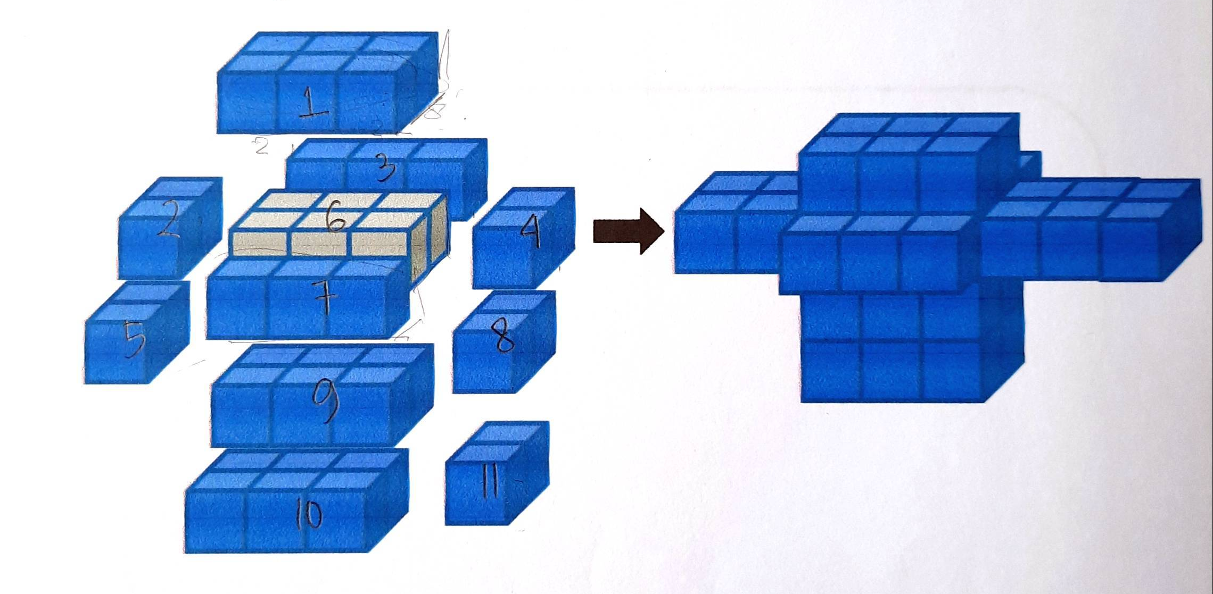
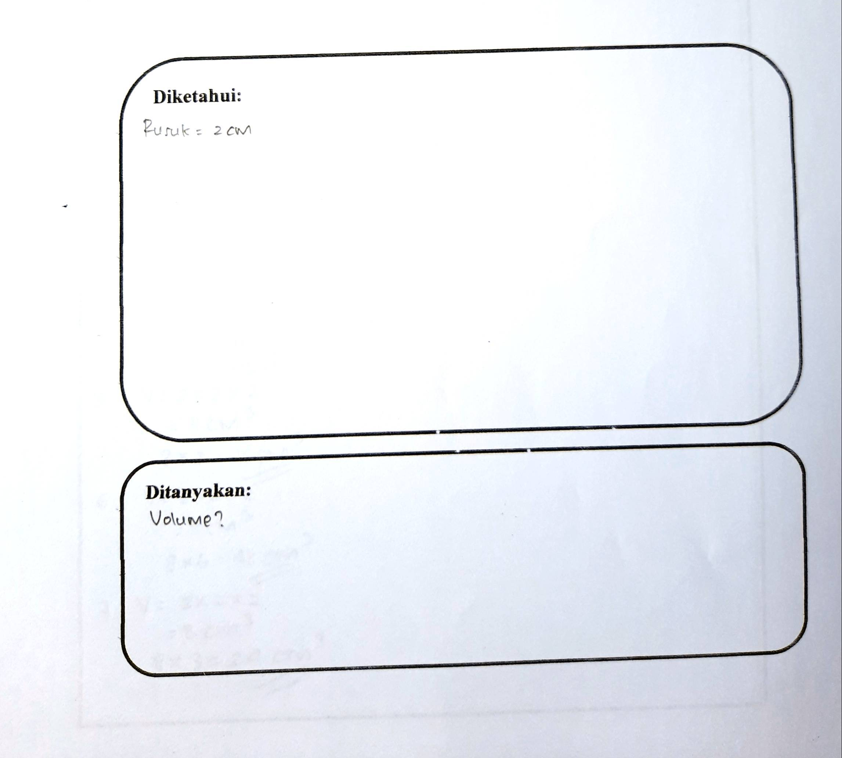
Asked:
Known:
Rib length = 2cm
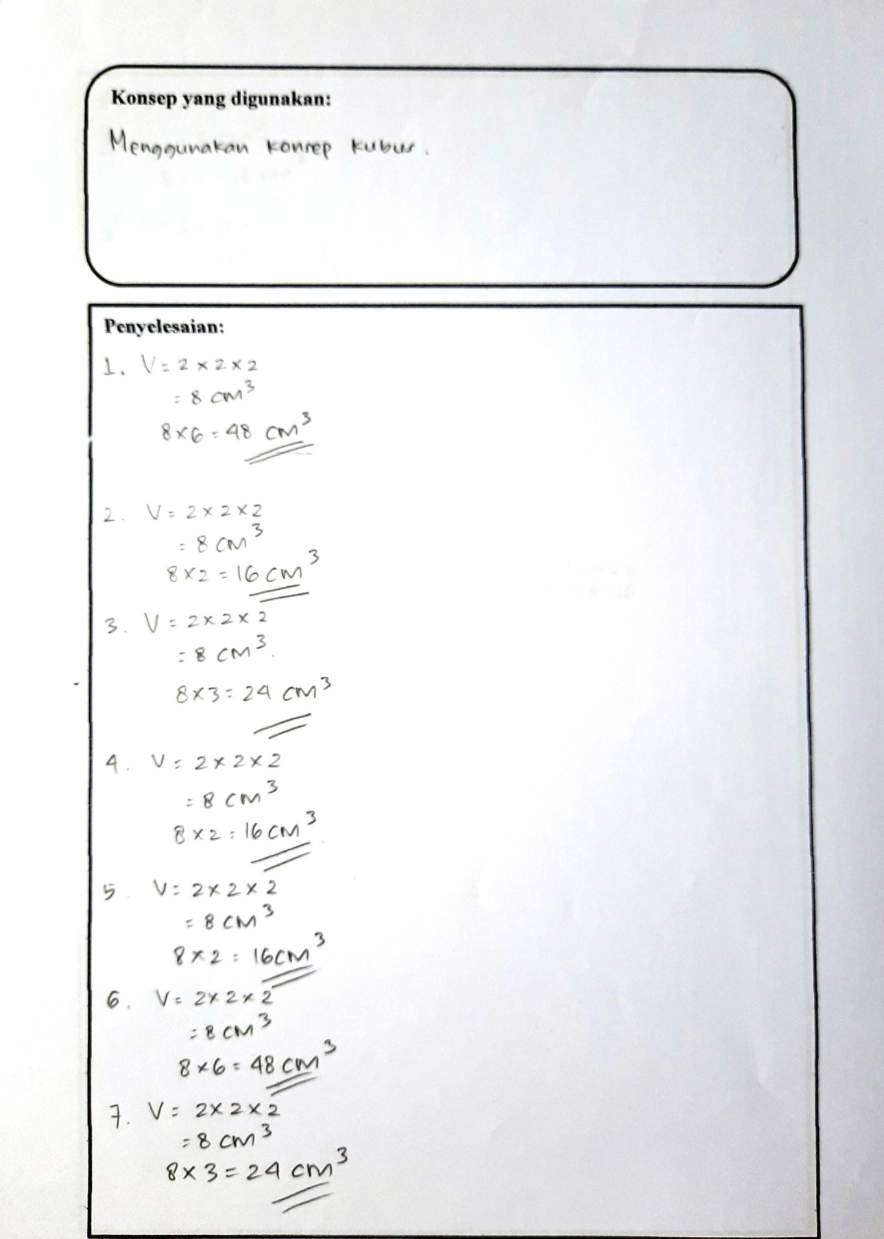
The answer:
Using the Cube Concept
The concept used:
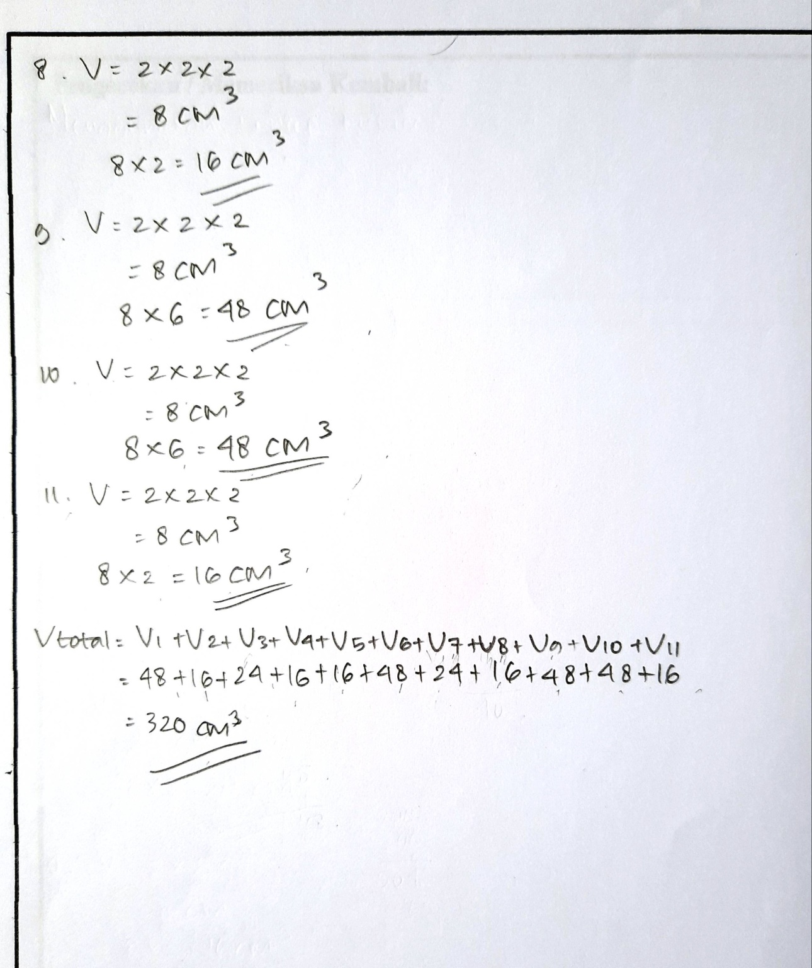
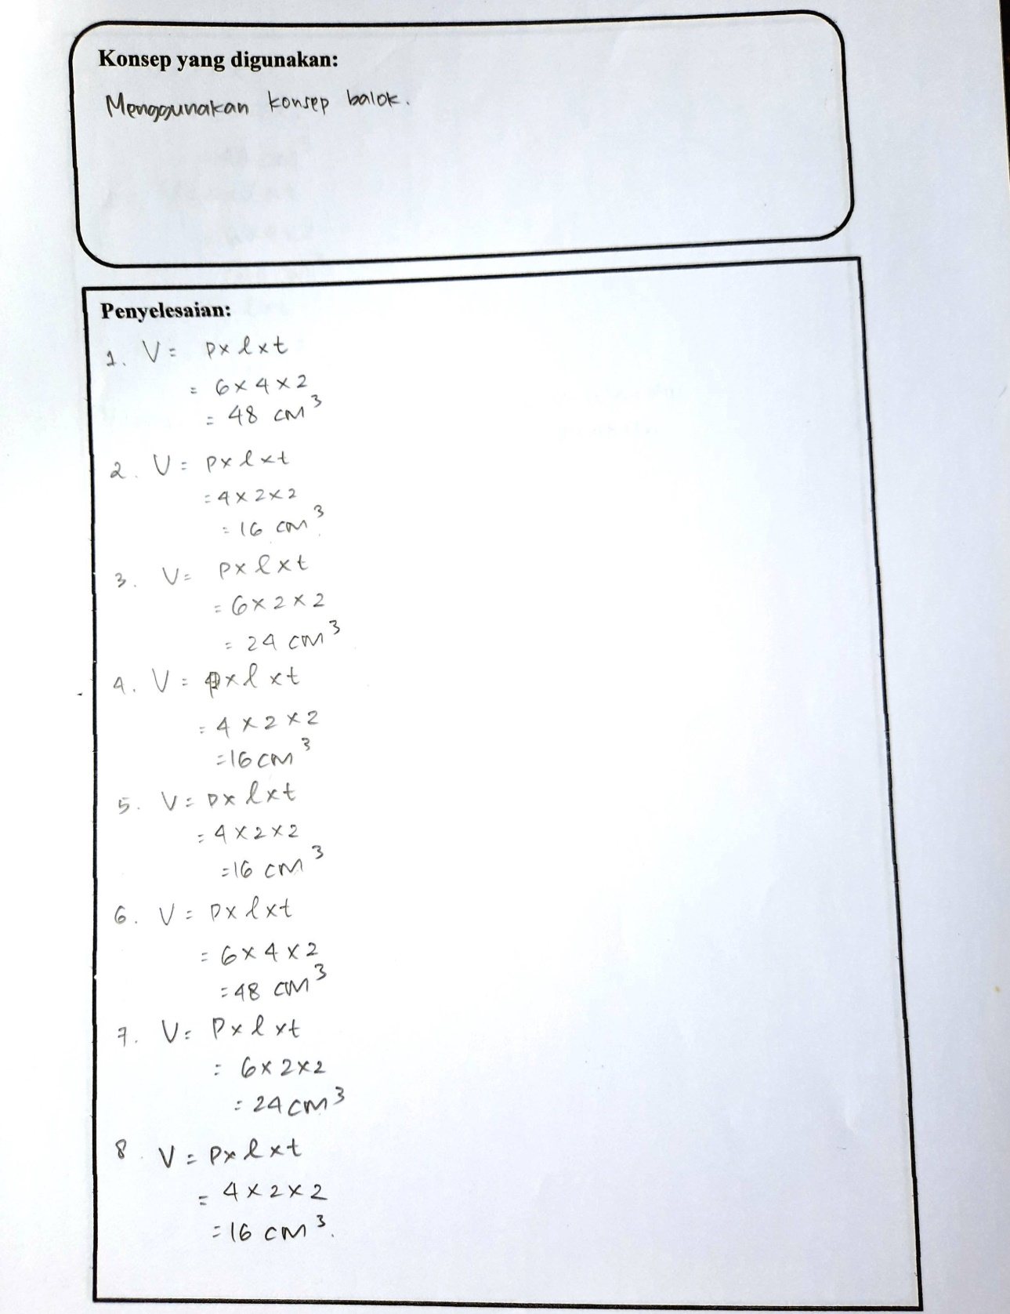
Using the Cuboid Concept
The answer:
The concept used:
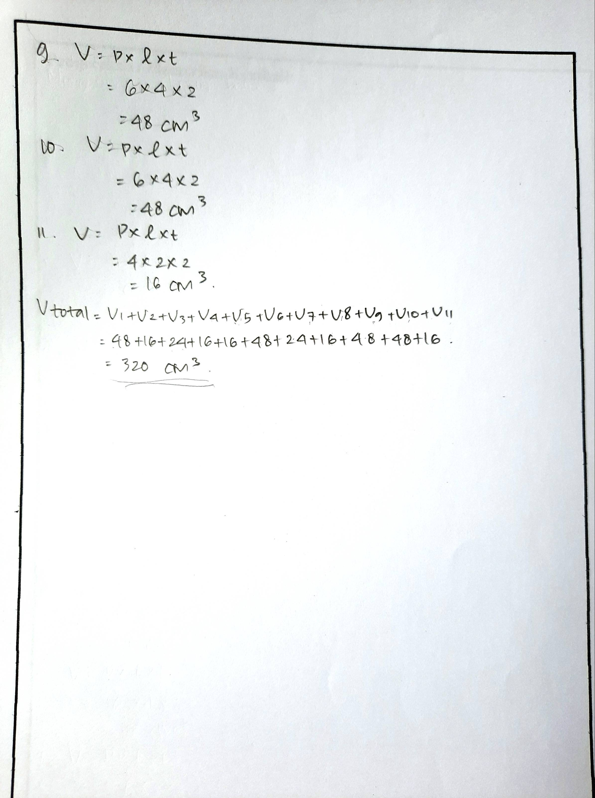

- Balance Brain Dominance Students Answers
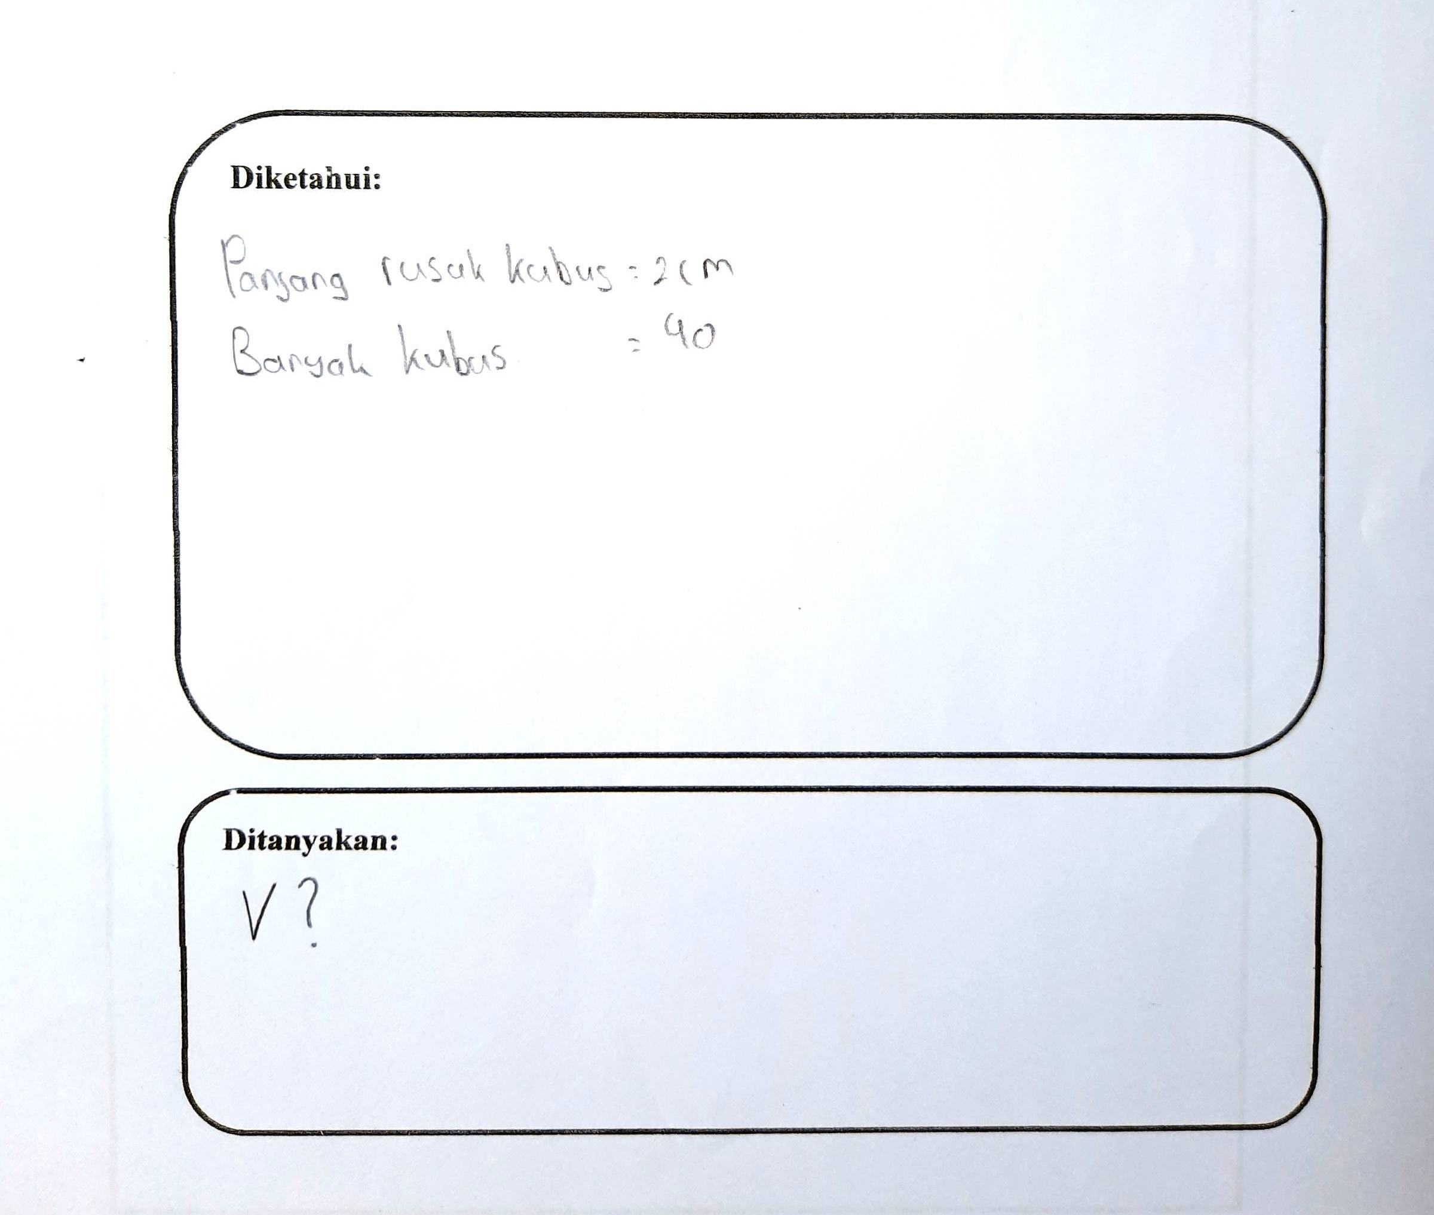
Asked:
Many Cubes = 40
Rib length = 2cm
Known:
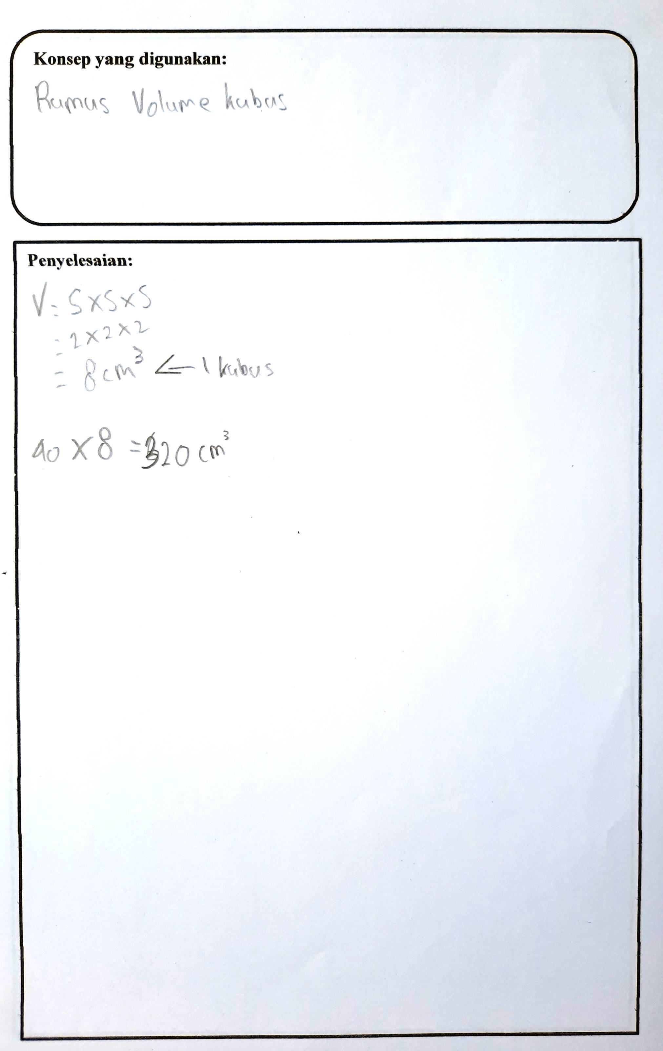
Answer:
The volume of one cube
Using the Cube Concept
The concept used:
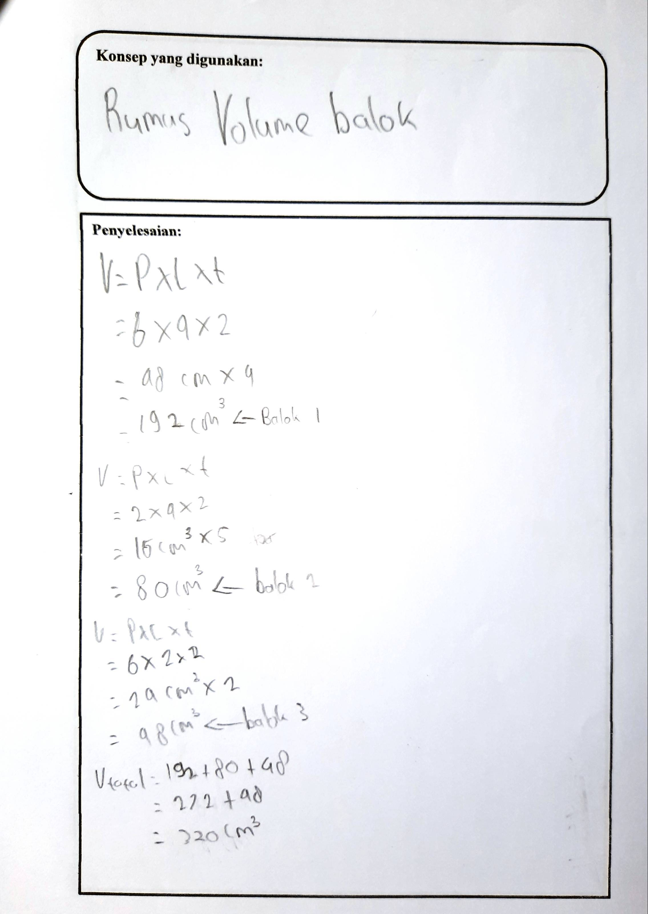
Cuboid 3
Cuboid 2
Cuboid 1
Answer:
Using the Cuboid Concept
The concept used:

- Right Brain Dominance Students Answers
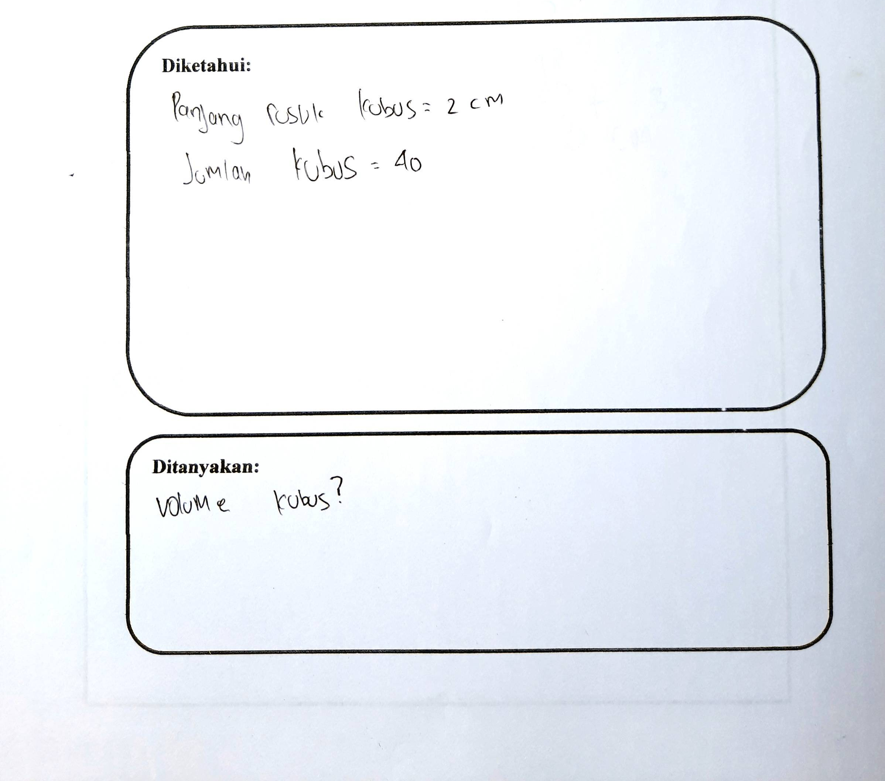
The Volume of Cube?
Rib length = 2cm
Asked:
Many Cubes = 40
Known:
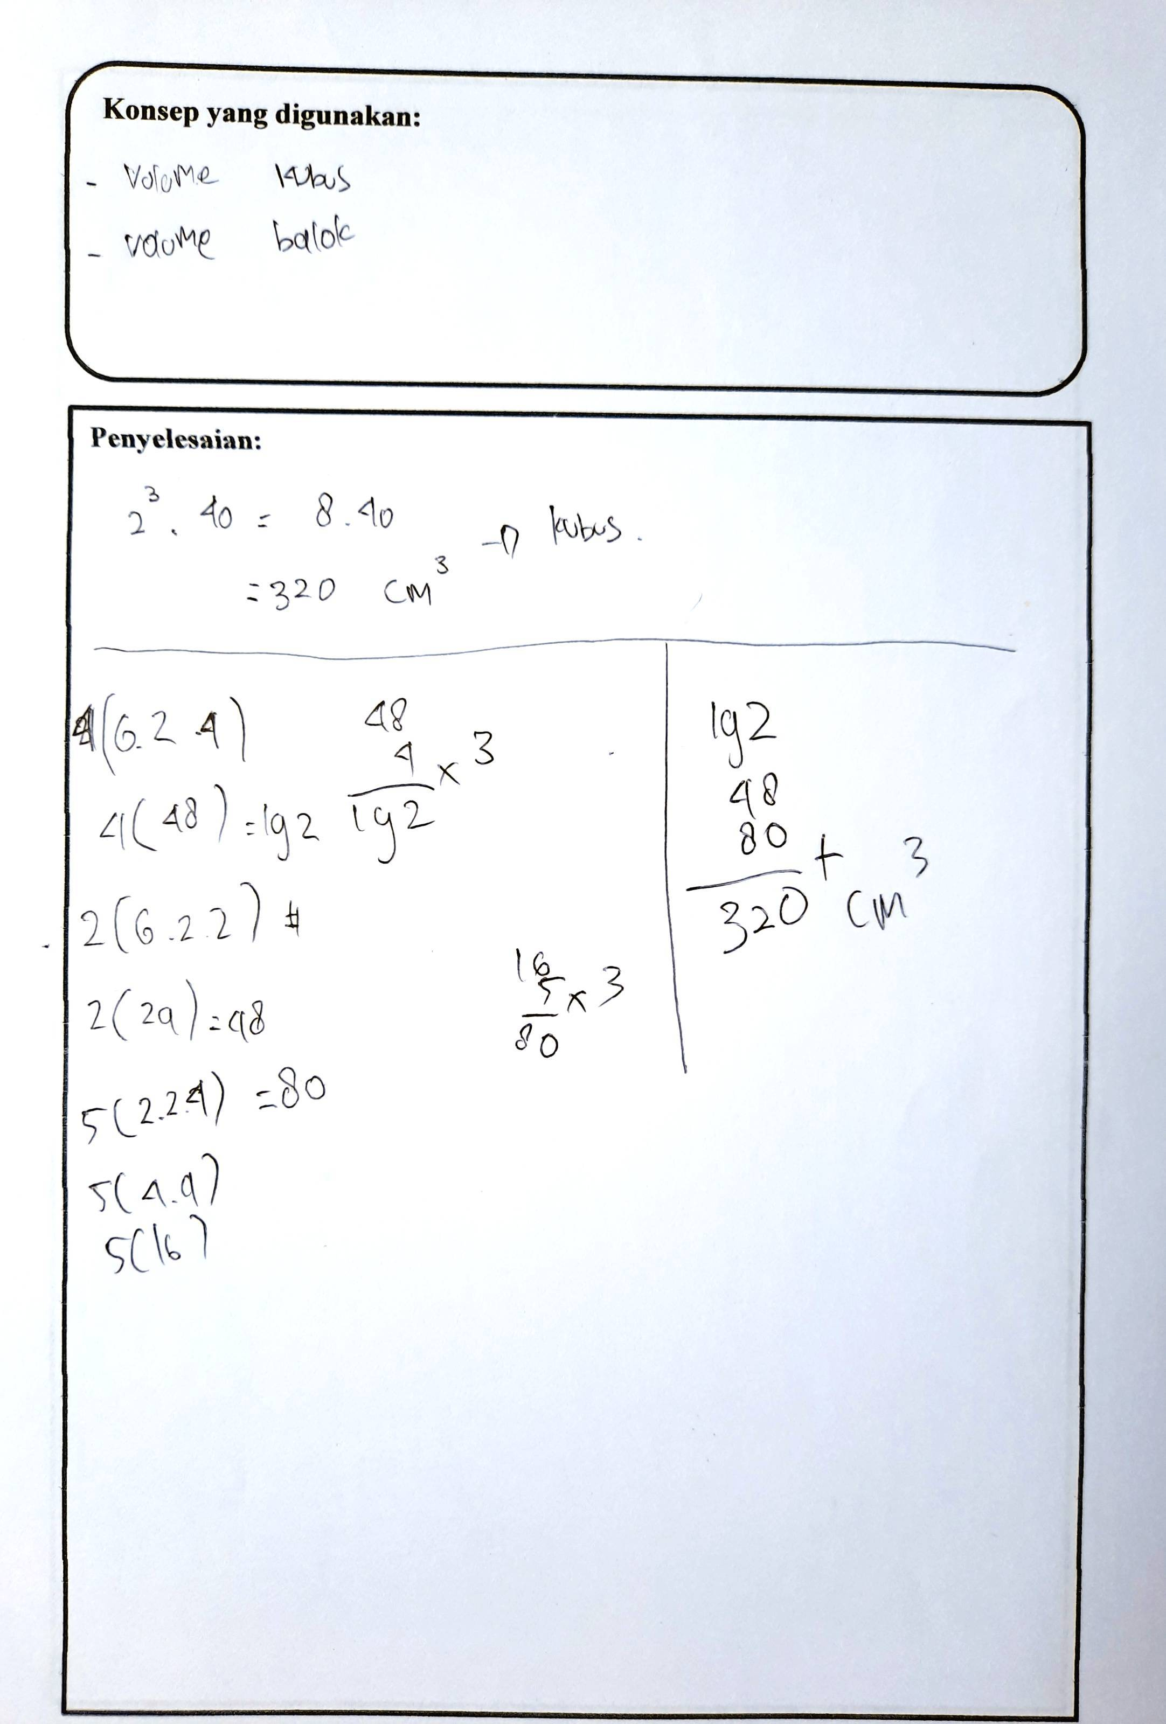
Cube
Volume Cuboid
Volume Cube
Answer:
The concept used:

